**DAILY ONLINE ACTIVITIES SUMMARY**

|  |  |  |  |  |  |  |  |  |
| --- | --- | --- | --- | --- | --- | --- | --- | --- |
| Date: | 27/05/2000 | | | | | Name: | Jyothi B R | |
| Sem & Sec | IV-A | | | | | USN: | 4AL18CS030 | |
| Online Test Summary | | | | | | | | |
| Subject | | Object Oriented Concepts | | | | | | |
| Max. Marks | | 30 | | Score | | | 27 | |
| Certification Course Summary | | | | | | | | |
| Course | Programming Essentials in Python | | | | | | | |
| Certificate Provider | | | Cisco Virtual Academy | | Duration | | | 2hrs |
| Coding Challenges | | | | | | | | |
| Problem Statement. bubble sort using c. | | | | | | | | |
| Status:Completed | | | | | | | | |
| Uploaded the report in Github | | | | | Yes | | | |
| If yes Repository name | | | | | https://github.com/alvas-education-foundation/jyothi_b_r | | | |
| Uploaded the report in slack | | | | | Yes | | | |

Online Test Details: (Attach the snapshot and briefly write the report for the same)

Certification Course Details: (Attach the snapshot and briefly write the report for the same)

Coding Challenges Details: (Attach the snapshot and briefly write the report for the same)

ONLINE TEST DETAILS:

The online test was from module 5. There were 30 questions which contains 30 mcq questions and the duration were 30 minutes. The questions were optimal and easy. The score that I received was 27/30.

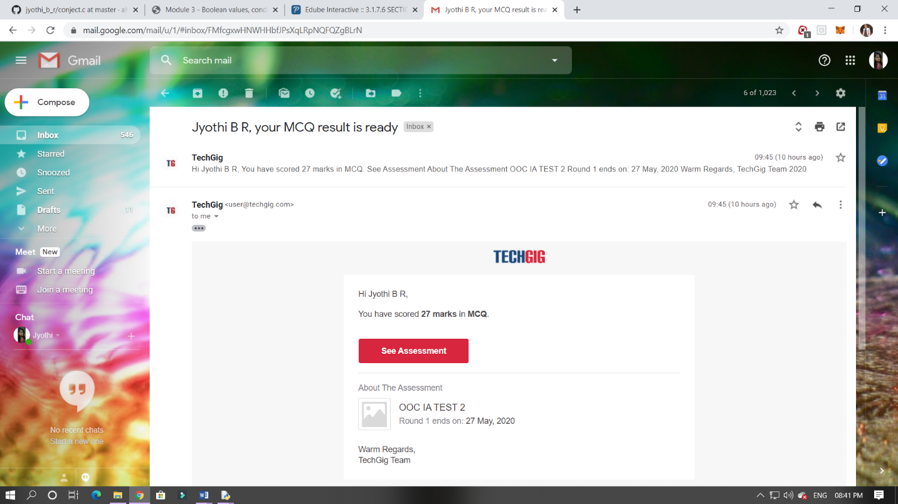

CERTIFICATION COURSE DETAILS:

Programming Essentials in Python :

List in Lists: two – dimensional arrays.

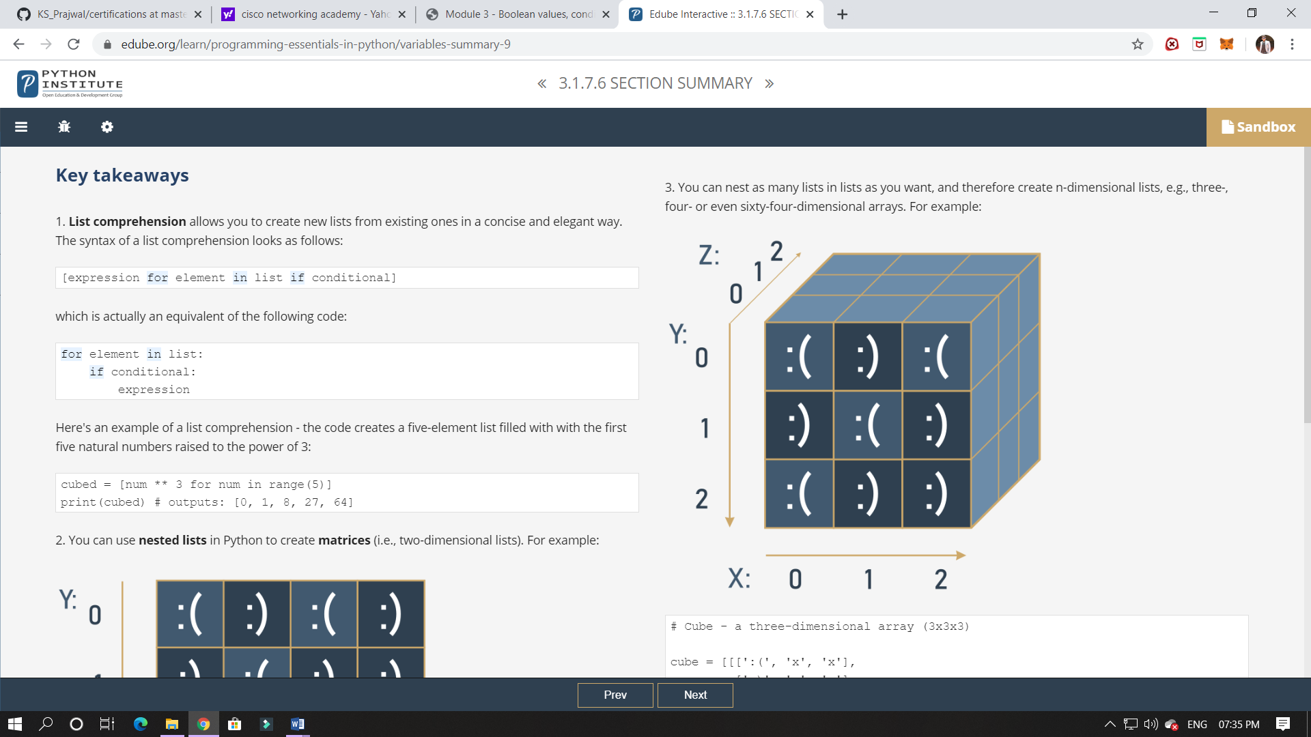

ONLINE CODING:

 In Bubble sort, each pass consists of comparison each element in the file with its successor (i.e. x[i] with x[i+1]) and interchanging two elements if they are not in the proper order. The array may be sorted in any pass. If the array is sorted, then remaining passes should be skipped off.Write a C Program to sort an array of integers in ascending order and display the sorted array and Number of passes performed for sorting.

